prevetting

Bunker Survey Company in Singapore

|  |
| --- |
| Tanker preVetting |

油轮检验

|  |  |  |
| --- | --- | --- |
| |  |  | | --- | --- | | In the marine tanker industry, two inspection regimes are predominant SIRE and CDI. SIRE inspections are commissioned by oil companies that are members of the OCIMF (Oil Companies International Marine Forum), Reports of such inspections are maintained on the OCIMF database for members to access, providing them up to date inspection status of the vessel.  c:\users\administrator\appdata\roaming\360se6\User Data\temp\images_q=tbn:ANd9GcSC-W7znwqJZDHggPbXillWV9u4gNwhCrL-T7kgIm-DAlqZfqgH.jpgc:\users\administrator\appdata\roaming\360se6\User Data\temp\images_q=tbn:ANd9GcQJYg-TO0VvoegAI6OarJRivAALUdQdSDamFdVJ29oHL--eSJ9_4A.jpg  c:\users\administrator\appdata\roaming\360se6\User Data\temp\images_q=tbn:ANd9GcQRpjjPW2mawzULOeJcFH9dDcUfdyx2-YJ8_EfWCwT_BaTM-AG9nQ.jpgc:\users\administrator\appdata\roaming\360se6\User Data\temp\images_q=tbn:ANd9GcTLwgsTGEw0fpTfbERxzL7UlcUpUJKH4WsPmjoAy-b576oAj7OQ.jpg   |  | | --- | | CG has been offering Bunker Surveying Services to Charterers and Ship Operators. The Service includes quantity checks  and ‘on the spot’ quality checks prior to bunkering. Thus ensuring that off spec bunkers do not enter the ship’s tanks. This in return prevent long-term machinery damage and off hire costs.  Our Bunker services are provided  by:   * Supported by Master Mariners with tanker experience * Quality checks for Density, Viscosity, Water content can be conducted ON THE SPOT PRIOR TO BUNKERING * 24 hours response arrangement * In-House Engineers for loss investigations   Bunker/ ROB surveys can be combined with On/ Off Hire condition Surveys | | |
| 船舶管理 |

          The company is specialized in international ship management, focus on ship maintenance, technical management, navigation security, crew manning, scheduling control, insurance claims, etc. We adhere to “acquire benefit from operating management” and “people oriented”, attach importance to scientific management, properly allocation, and control cost in the premise of keeping safety. We realize scientific and reasonable increasing income and reducing expenditure through large-scale procurement, purchase by biding, encouraging self-repair, fuel and energy saving. Through these efforts, we successfully met the challenges from the severe market, presented a good development state.

公司团队&ABOUT US

 The executive director, general manager, vice general manager and core team has held the post in well-known management company in and around world for more than fifteen years. The key personnel come from famous ship owner company, ship management company and chartering company. We have senior captains, senior chief engineers, crew managers and international shipping business managers among our team.  
        who are graduated from Singapore, National University, Dalian Maritime University, Shanghai Maritime University and other accredited professional universities domestic and

overseas, experienced as the captain, chief engineer and surveyor for many years. The team members are experienced in navigation, skilled in ship management and mastered in the international ship chartering.

海事顾问

Our new building projects are manned by a well-rounded team comprising of Marine Engineers, Naval Architects, Production Engineers, Electrical Engineers and Senior Ship Officers, with both ship building and operational experience for various vessel types thus ensuring that vessels are built not only to suit commercial requirements but also to ensure operational practicality

Delivery

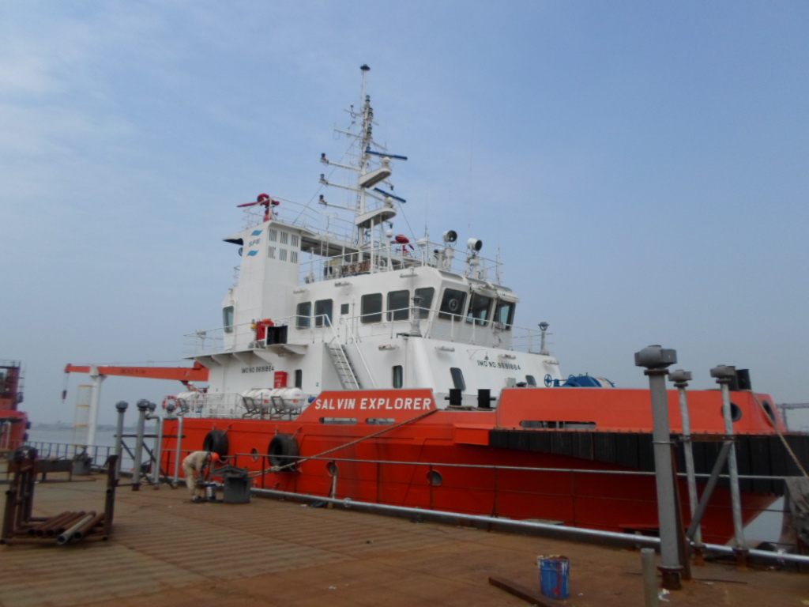

Our new building projects are manned by a well-rounded team comprising of Marine Engineers, Naval Architects, Production Engineers, Electrical Engineers and Senior Ship Officers, with both ship building and operational experience for various vessel types thus ensuring that vessels are built not only to suit commercial requirements but also to ensure operational practicality

Pilot service

Pilot service(可以空白)

Repair

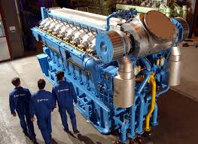

Repairing projects of offshore engineering,

¨ Special painting projects for cargo holds and ballast-water

　 compartments of product tankers and chemical product

　 vessels,

¨ Maintenance and repair of adjustable propeller,

¨ Maintenance and repair services for specialized supercharger,

¨ Repairing of speed governor,

¨ Hot painting and spraying,

¨ Renovation of the worn parts,

¨ Repairing of boilers,

¨ Repairing of hydraulic systems,

¨ Repairing of communication and navigation systems.